# Integration of VL53L3CX breakout board on 96board dragon board 410C

## Hardware adaptation

We use an AISTAR MIPI Adapter between Ewok+ VL53L3CX satellite and the board 410C

<https://github.com/Kevin-WSCU/96Boards-Camera/tree/master/AISTARVISION%20MIPI%20Adapter%20V2.1>

The VL53L3CX satellite connected to the adapter board on top of a dragon board 410c

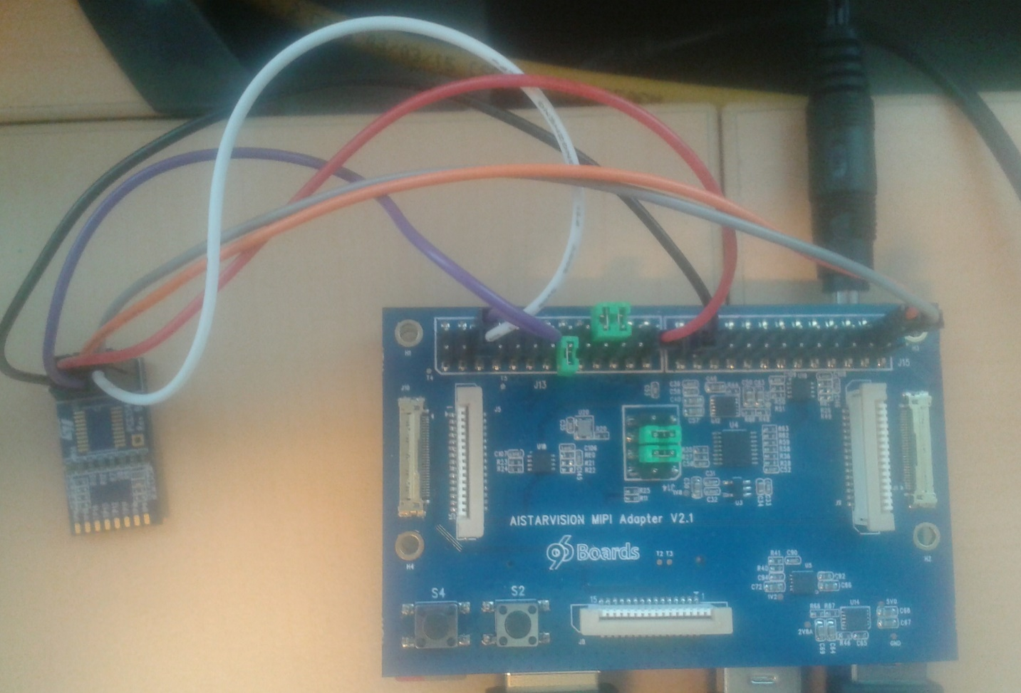

VL53L3CX exposes I2C, Xshutdown and Interrupt pins which must be connected to respective I2C and GPIOs on board 410C through the AISTAR MIPI Adapter.

Adapter J13 & J15 connectors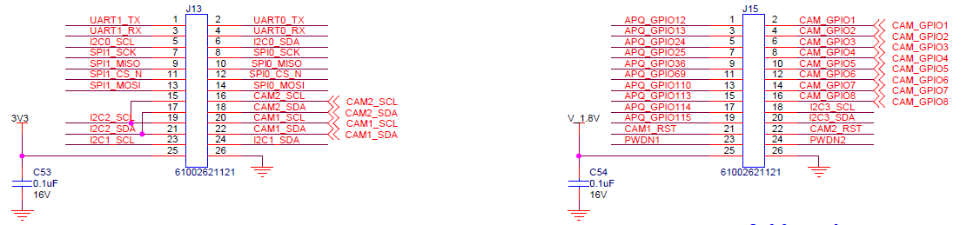

VL53L3CX Satellite

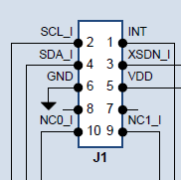

* Connect VL53L3CX pins 2-4 to I2C0 located on pins 5-6 connector J13 on the adapter
* Connect Int (VL53L3CX J1 pin 1) to Gpio 12 pin 1 connector J15 on the adapter
* Connect Xsdn (VL53L3CX J1 pin 3) to Gpio 13 pin 3 connector J15 on the adapter
* 3V3 applied on VL53L3CX J1 pin 5 is taken from pin 25 connector J13 on the adapter
* GND VL53L3CX J1 pin 6 is fitted on pin 26 connector J15 on the adapter

## Software requirements

Linux driver version l3cx_release_1.0.3 has been used on Linaro based linux version 4.14.15-st

Source code on SVN : <http://codex.cro.st.com/svnroot/ewokp25/LinuxDriver/tags/l3cx_release_1.0.3/>

### Instruction for build kernel+daemon and run basic tests through phio user application

#### Driver build

export KDIR/home/linaro/linux-headers

export DRIVER_DIR=<location where you put the package of the linux driver>

export DRIVER_DIR=${DRIVER_DIR}/driver/vl53Lx/

cd $DRIVER_DIR

make clean

make

#### Driver installation

sudo insmod stmvl53lx.ko force_device=1 adapter_nb=0 xsdn_gpio_nb=13 intr_gpio_nb=12

sudo chmod 777 /dev/stmvl53lx_ranging

#### Daemon build & launch

cd $DRIVER_DIR/../../android/hardware/vl53lx_daemon/

sudo make CC=gcc clean all test

./vl53lx_daemon_main &

#### User space test application build

cd $DRIVER_DIR/../../android/hardware/vl53lx_test/

make CC=gcc clean all

#### Launching user space test application

Existing options can be displayed thanks to --help option

./phio --help

Launch 10 ranging measurements

./phio -s -Z=10 -S

### Instruction for build full kernel driver and run basic tests through phio user application

#### Driver build

export KDIR=/home/linaro/linux-headers

export DRIVER_DIR=<location where you put the package of the linux driver>

export DRIVER_DIR=${DRIVER_DIR}/driver/vl53Lx/

cd $DRIVER_DIR

make clean

make VL53LX_FULL_KERNEL=1

#### Driver installation

sudo insmod stmvl53lx.ko force_device=1 adapter_nb=0 xsdn_gpio_nb=13 intr_gpio_nb=12

sudo chmod 777 /dev/stmvl53lx_ranging

#### User space test application build

cd $DRIVER_DIR/../../android/hardware/vl53lx_test/

make CC=gcc clean all

#### Launching user space test application

Existing options can be displayed thanks to --help option

./phio --help

Launch 10 ranging measurements

./phio -s -Z=10 -S